Victor Nikulin
Grigory Ryazanov
Vyacheslav Grigoryev
Vladimir Logichev

ANALOG
SYNTHESIZER

РИТМ-2

USER’S MANUAL

2018
5024966@gmail.com
v1.0
1. GENERAL INSTRUCTIONS

Upon purchasing the “РИТМ-2” (pronounced “ritm dva”) analog synthesizer check:
- the package for any damage;
- that all the parts are included;
- that the synthesizer is working properly.
Before turning the synthesizer on, read this user’s manual to familiarize yourself with the layout of the controls and their functions as well as the connectors for external inputs.

2. PACKAGE CONTENTS

  - “РИТМ-2” analog synthesizer
  - Power cord
  - Fuse
  - User’s manual

3. IMPORTANT SAFETY INSTRUCTIONS

The “РИТМ-2” analog synthesizer is designed to work only from a 220V AC power outlet.
Before changing the fuse, make sure to unplug the synthesizer from the power outlet. Do not use any homemade or DIY fuses.
Do not leave the synthesizer plugged into the power outlet if not in use.
The synthesizer is not intended for use in humid conditions or in temperatures below 5°C or above 45°C.
All control knobs have strictly fixated positions and should turn easily Avoid exerting too much force to rotate them.
Protect the instrument from damage, being dropped, receiving heavy blows and exposure to moisture.

4. SYNTHESIZER CONFIGURATION

The “РИТМ-2” synthesizer from VGLine is a remake of the legendary Soviet synthesizer “РИТМ-2” that was produced in the city of Kirov from 1984 to 1993. The remake is based on the original schematics of the Soviet “РИТМ-2” synthesizer, that was designed and developed by the engineer Viktor Anatolyevich Nikulin. The remake uses original Soviet electronic components. This guarantees that the “РИТМ-2” completely replicates the sonic qualities of the original synthesizer. However, the functionalities of the remake synthesizer have been significantly expanded.
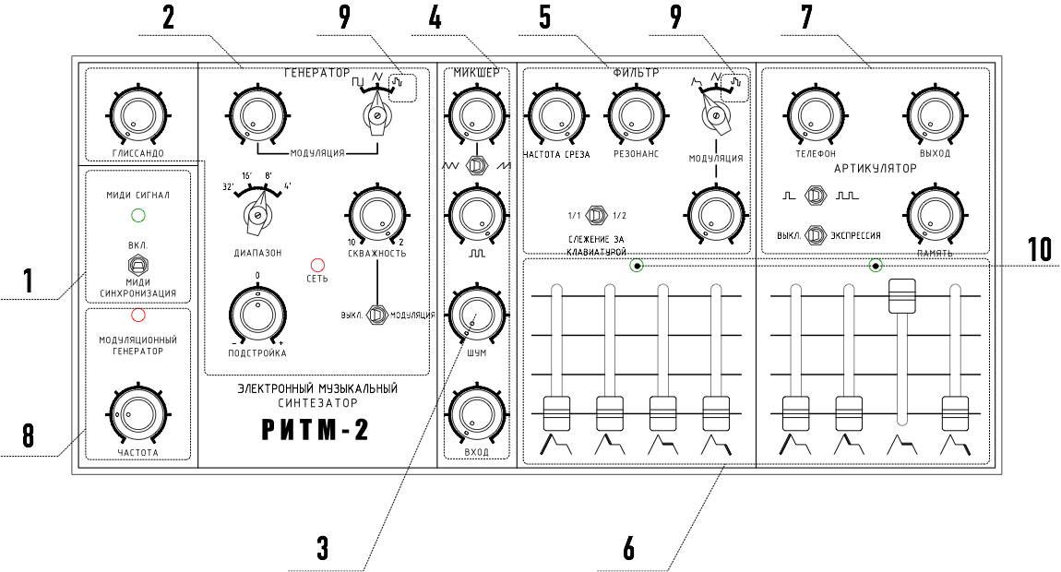
The “РИТМ-2” analog synthesizer (fig. 1) is a monophonic analog musical instrument designed for solo, group or orchestral performance of various musical genres. It can also be used for educational purposes and for creating new sonic effects. The “РИТМ-2” can be incorporated into live performances as well as into a home or recording studio.
Fig 1. “РИТМ-2” analog synthesizer control panel.

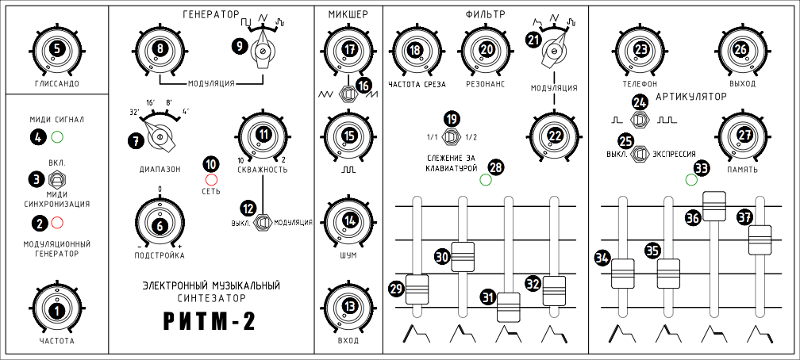
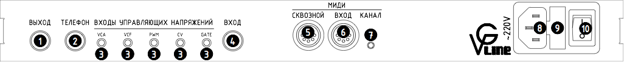
The “РИТМ-2” allows you to create your own unique sounds, imitate classical musical instruments (keyboard, string, reed, percussion) and create original sonic effects (the sound of wind, a train passing by, the sound of waves crashing or a gunshot, for example). You can also create melodies on the synthesizer that change randomly in pitch and timbre.
Fig. 2 Control parameters
Fig. 3 Back panel with connectors for external control inputs

The “РИТМ-2” analog synthesizer consists of the following main blocks (fig. 1):

- External connection block — for receiving MIDI and CV (control voltage) signals from connected external MIDI and CV devices.
- Tone generator (VCO) — voltage controlled oscillator and main source of sound signal.
- Noise generator (NOISE) — source of noise.
- Mixer (MIX) — combines signals from the tone generator, external audio source and the noise generator.
- Voltage controlled filter (VCF) — voltage controlled filter that is used for the creation of timbre. When placed into self-oscillation mode, the filter can be used to create sinusoidal waves.
- 2 Envelope generators (EG) — one of which is used to modulate the depth of the filter cutoff frequency and the other —as an envelope used to modulate amplitude.
- Voltage controlled amplifier (VCA) — voltage controlled amplifier used for expression and to modulate the amplitude of the signal exiting the filter with the envelope from the second EG.
- Low frequency oscillator (LFO) — modulates the frequency of the tone generator with triangle or rectangle waves; creates pulse-width modulation of the tone generator’s rectangle wave with a triangle wave; modulates the filter cutoff frequency with a triangle wave. The modulation generator’s frequency can be visually adjusted using the periodically flashing LED light located on the control panel. The LFO can also be synchronized to a MIDI clock.
- Random voltage generator (S&H) modulates the tone generator and the filter cutoff frequencies. The amount of random voltage levels produced depends on the regulation of the modulation speed.
- LED indicating that the envelope is being triggered

Controls and LEDs (fig. 2):
- “FREQUENCY” knob regulates the frequency of the modulation generator.
- LED for visual control of the LFO frequency.
- Toggle switch to turn on LFO synchronization to a MIDI-clock signal.
- Multi-colored LED for visual control of MIDI signals coming from external sources.
- “GLIDE” knob regulates the tone generator’s time of transition from one note to another. Time of transition varies from 5 msec. to 5 sec.
- “TUNE” knob allows precise tuning of the instrument.
- “OCTAVE” switch sets the instrument’s octave range: 32’, 16’, 8’, 4’ ft.
- “MODULATION” knob regulates the amount of modulation applied to the tone generator.
- “MODULATION” switch selects the source of the tone generator’s modulation:
— rectangle wave from LFO;
— triangle wave from LFO;
— random voltage generator (S&H).
- CROSSFADING COLOR “POWER” LED indicates that synthesizer in powered on.
- “PULSE WIDTH” knob regulates the pulse width of the rectangle signal from the tone generator from 10 to 2.
- “MODULATION” toggle switch turns on pulse-width modulation.
- “INPUT LEVEL” knob regulates the signal level from external source.
- “NOISE” knob regulates the noise generator’s signal level.
- knob regulates the level of the rectangle wave from the tone generator.
- , toggle switch selects triangle or sawtooth wave for the tone generator signal.
- , knob regulates the triangle or sawtooth wave signal level from the tone generator.
- “CUTOFF” knob regulates the filter cutoff frequency.
- “KEYTRACK” toggle switch. In 1/1 position the filter sets itself to the same interval as the tone generator. In the 1/2 position the filter sets itself to an interval half of that of the tone generator.
- “RESONANCE” knob regulates the filter Q-factor from minimal to generating frequencies at the cutoff frequency.
- “MODULATION” switch selects the type of modulation applied to the filter cutoff frequency:
— envelope from the first envelope generator;
— triangle wave from the LFO;
— random voltage generator (S&H).
- “MODULATION” knob regulates the amount of modulation applied to the filter cutoff frequency.
- “PHONES” knob regulates the volume of the headphone signal.
- , toggle switch selects the second envelope generator’s mode:
— one-shot trigger when a key is pressed;
— the second envelope generator is triggered repeatedly while a key is pressed. Knobs 34 and 37 regulate the speed of repetition and the envelope shape in this mode.
- “VELOCITY” toggle switch turns on the VCA’s reaction to the “Velocity” parameter of any incoming MIDI signal (keyboard, sequencer, etc.)
- “VOLUME” knob regulates the level of the output signal.
- “HOLD” knob regulates the amount of signal that remains audible after releasing the last pressed key. The signal from the filter is continuously sent to the synthesizer output.
- LED for visual indication that the filter’s envelope generator is being triggered.
- fader — attack. Sets the time during which the filter cutoff frequency increases from the value set by the “CUTOFF” knob to the value set by the “MODULATION” knob.
- fader — decay. Sets the time during which the filter cutoff frequency decreases from the value at the moment the attack finishes to the frequency set by the (sustain) fader.
- fader — sustain. Sets the level of the filter cutoff frequency for the time between when the decay finishes and the key is released.
- fader — release. Sets the time during which the filter cutoff frequency decreases from the value set by the (sustain) fader to the value set by the “CUTOFF” knob after the key is released.
Faders 29, 30, 31 and 32 are active when the “MODULATION” control (see 21) is set to the (envelope) position.
- LED for visual indication that the amplifier’s envelope generator is being triggered.
- fader — attack. Sets the time that the output signal increases in amplitude from nil to peak.
- fader — decay. Sets the time that the output signal decreases in amplitude from the peak to the level set by the (sustain) fader.
- fader — sustain. Sets the level of the output signal that is sustained for the time between when the decay finishes and the key is released.
- fader — release. Sets the time during which the output signal decreases in amplitude from the sustain level to zero after the key is released.
Control faders 34, 35, 36, 37 are active when the “HOLD” knob (see 27) is turned all the way to the left.
When toggle switch 24 is in position , control faders 34 and 37 set the speed of repetition and envelope shape.

On the back panel of the synthesizer are located (fig. 3):
- “OUTPUT” for connecting the synthesizer to a power amp, mixer, audio interface, etc.
- “PHONES” for connecting to headphones.
- Group of “CV INPUTS” for controlling the synthesizer’s internal blocks from external control voltage sources (modular synthesizers, CV sequencers, etc).
VCA — controls synthesizer amplifier. If the internal envelope generator (EG) is used as a source of amplifier modulation, an external signal sent to this input will be added to the internal EG signal. An external modulation generator can also be used for amplitude modulation.
VCF — controls the filter cutoff frequency. If internal modulation is applied to the cutoff frequency, an external source of modulation sent to this input will be added to the internal modulation signal.
PWM — controls pulse-width modulation. If an internal source of pulse-width modulation is used, the external signal sent to this input will be added to the internal modulation signal.
CV — controls the pitch. If an internal source of modulation is used for the pitch, an external signal sent to this input will be added to the internal modulation signal. The tone generator can also be set to produce the chromatic scale when 1V/Oct is sent to this input.
GATE — external signal triggers envelope generators.
- “INPUT” for sending a signal from any external music instrument or audio source to the synthesizer’s mixer.
- “MIDI THRU” for connecting MIDI-compatible instruments. The port provides a direct copy of all MIDI signals coming through the “MIDI IN”.
- “MIDI IN” for connecting a MIDI keyboard or any other source of MIDI signals (MIDI-controller, sequencer, computer).
- “MIDI LEARN” button — sets MIDI Receive Channel.
- Power supply connector for plugging synthesizer into a power source.
- Fuse holder which also contains a backup fuse included with the synthesizer.
- Power switch.

5. MAIN TECHNICAL CHARACTERISTICS
Synthesizer frequency range

Numbers of available MIDI channels.
“PITCH” control interval, semitones
factory setting
user setting
MIDI Cutoff control range
MIDI Velocity range
External CV input range
Instrument tune drift no more than
Linear frequency drift of oscillator after 4 hours of continuous activity no more than
Output signal amplitude no less than
Output signal amplitude range
Mains supply V, with 50 Hz frequency

Power consumption no more than
Application temperature range
Synthesizer dimensions
Weight
7 octaves from note C in the first octave to note C in the fifth octave.
1-15

+/-2
+/-12 (max.)
0-127
0-127
0-5 V
5 cents

10 cents
0.775 V
60dB
220±10% (110 optional)
10 W
from +5 to +45°C
385 x 180 x 105 (mm)
3 kg

6. MIDI CONTROL AND “SysEx”

The built-in MIDI converter has the following control options: a MIDI-Learn button (fig.3. 7), a “MIDI SYNC” switch (fig.2. 3), a multicolored “MIDI” LED indicating MIDI-converter activation when lit up (fig.2. 4). The multicolored LED lights up red to signal any MIDI activity when a MIDI cable is connected to the MIDI IN.
“MIDI LEARN” button. To assign a designated MIDI Channel to the “РИТМ-2” synthesizer, press and hold the “MIDI Channel” button until the MIDI LED lights up blue. After this, press any note on the sequencer or MIDI-keyboard and the assigned channel (except for 16) that transmitted the MIDI message will be memorized. The blue light will go out and each incoming note will be indicated by the LED lighting up green. Also, a desired MIDI channel can be assigned using SysEx messages (see Table 1).
“MIDI-SYNC” switch. The built-in MIDI converter accepts “MIDI CLOCK” messages and translates them into a pulse that synchronizes the LFO frequency with the external sequencer tempo. To do this, turn on the sequencer’s “MIDI CLOCK send to external hardware” option (see sequencer’s user’s manual). To synchronize the LFO with the external sequencer tempo, place the “MIDI SYNC” switch to “ON” position (fig.2 3) and turn the “FREQUENCY” knob (fig.2 1) to its minimal position. The LFO LED (fig.2 2) will light up in sync with the external sequencer tempo. Interesting modulation effects, synchronous with the external sequencer tempo, can be achieved by adjusting the “FREQUENCY” knob to increase the modulation frequency.
The synthesizer is capable of receiving MIDI Notes from 0 to 127 and recognizes MIDI commands “NOTE ON” and “NOTE OFF”. An external “PITCH” wheel can be used. The factory setting is set to a +/- 2 semitone range, but this can be adjusted using SysEx commands (see Table 1).
The synthesizer recognizes MIDI Velocity values in a range of 0-127. To use this function for expression, turn the “VELOCITY” switch (fig. 2 25) to “VELOCITY” position. This will cause every note to be played with corresponding velocity. When the “VELOCITY” switch (fig. 2 25) is turned to “OFF” all notes will be played at their maximal velocity value (127) and will be played at a constant maximal volume.
MIDI filter cutoff frequency control. This can be achieved using MIDI controller CC#1. It has a value of 0 to 127 and controls the entire range of the filter cutoff frequency. The initial cutoff frequency value can be set using the “CUTOFF” knob (fig.2. 18)
MIDI SysEx can be used to set MIDI Channel, Pitch Wheel range and Note Priority.

Таблица 1
Midi2cv SysEx codes

midi_channel set
F0 00 20 21 7F 55 00 00 2B F7 // 1 channel
F0 00 20 21 7F 55 00 01 2A F7 // 2 channel
F0 00 20 21 7F 55 00 02 29 F7 // 3 channel
F0 00 20 21 7F 55 00 03 28 F7 // 4 channel
F0 00 20 21 7F 55 00 04 27 F7 // 5 channel
F0 00 20 21 7F 55 00 05 26 F7 // 6 channel
F0 00 20 21 7F 55 00 06 25 F7 // 7 channel
F0 00 20 21 7F 55 00 07 24 F7 // 8 channel
F0 00 20 21 7F 55 00 08 23 F7 // 9 channel
F0 00 20 21 7F 55 00 09 22 F7 // 10 channel
F0 00 20 21 7F 55 00 0A 21 F7 // 11 channel
F0 00 20 21 7F 55 00 0B 20 F7 // 12 channel
F0 00 20 21 7F 55 00 0C 1F F7 // 13 channel
F0 00 20 21 7F 55 00 0D 1E F7 // 14 channel
F0 00 20 21 7F 55 00 0E 1D F7 // 15 channel
pitch_bend_range set
F0 00 20 21 7F 55 01 01 29 F7 // 1 semitone
F0 00 20 21 7F 55 01 02 28 F7 // 2 semitone
F0 00 20 21 7F 55 01 03 27 F7 // 3 semitone
F0 00 20 21 7F 55 01 04 26 F7 // 4 semitone
F0 00 20 21 7F 55 01 05 25 F7 // 5 semitone
F0 00 20 21 7F 55 01 06 24 F7 // 6 semitone
F0 00 20 21 7F 55 01 07 23 F7 // 7 semitone
F0 00 20 21 7F 55 01 08 22 F7 // 8 semitone
F0 00 20 21 7F 55 01 09 21 F7 // 9 semitone
F0 00 20 21 7F 55 01 0A 20 F7 // 10 semitone
F0 00 20 21 7F 55 01 0B 1F F7 // 11 semitone
F0 00 20 21 7F 55 01 0C 1E F7 // 12 octave
note priority SysEx
F0 00 20 21 7F 55 03 00 28 F7 // lowest note priority
F0 00 20 21 7F 55 03 01 27 F7 // highest note priority
F0 00 20 21 7F 55 03 02 26 F7 // last note priority

*MIDI Converter created with software from Mr. Logich

7. SETTING UP THE SYNTHESIZER

To prepare the synthesizer for operation you need to:
— Place the synthesizer on a stable surface at a comfortable height for playing.
— Connect the MIDI OUT of your sequencer or MIDI Keyboard into the synthesizer’s MIDI IN (fig.3 6).
— Plug the power supply cord to a 220V power outlet (fig.3 8).
— Connect the OUTPUT (fig.3 1) to an amplifier using an instrument cable.
— Turn the synthesizer power switch on (fig.3 10) and let it warm up for at least 5 minutes.
— To make the best use of the instrument, the player should familiarize him/herself with the synthesizer’s full range of functions and capabilities.

WARNING: If the synthesizer was kept in an environment where air temperature fell below +5°C, prior to playing, leave the instrument in an environment with room-temperature (+23°C) for at least 2-3 hours.
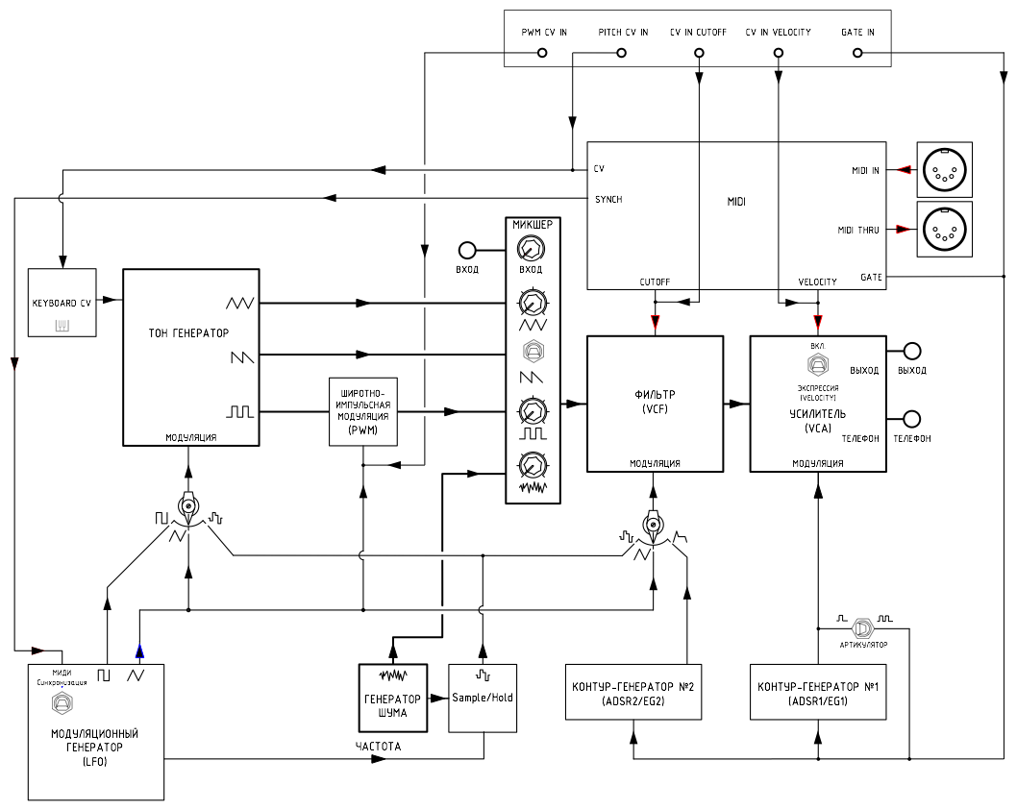
Fig.4 “RITM-2” block diagram
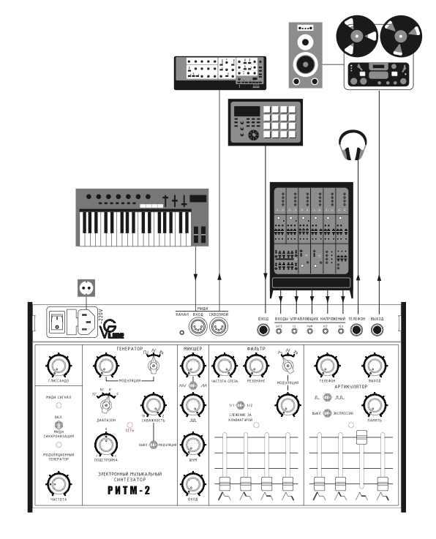

Fig.5 Synthesizer connection diagram

WARRANTY
The warranty period for the РИТМ-2 synthesizer is 2 years from the date of its sale.

This limited hardware warranty covers defects in materials and workmanship in your VG-Line-branded products, including synthesizer РИТМ-2.
This limited hardware warranty does not cover:
- Non VG-Line-branded products and accessories
- Problems that result, directly or indirectly, from:
- External causes such as accident, abuse, misuse or problems with electrical power.
- Servicing not authorized by VG-Line.
- Usage that is not in accordance with product instructions.
- Failure to follow the product instructions or failure to perform preventive maintenance.
- Using accessories, parts or components not supplied by VG-Line.
- Commercial hardware products that use, or in which have been installed, products or components that have not been provided by VG-Line.
- Products with missing or altered service tags or serial numbers
- Products for which VG-Line has not received payment
- Damage to the finishes of the case and side panels caused by exposure to moisture, corrosive media, mechanical stress
- Normal wear and tear
For commercial customers (including small, medium and large business and government and public sector customers) and resellers. This paragraph applies if you purchase VG-Line products for resale or for commercial or professional purposes. VG-Line responsibility for defects in materials or workmanship is limited to repair or replacement of the product as set forth in this warranty statement. Except for the limited warranty expressly stated above for VG-Line -branded products, VG-Line provides no warranties or conditions, express or implied, including but not limited to any warranty or condition (1) of merchantability, merchantable quality, fitness for a particular purpose, performance, suitability or noninfringement; (2) relating to any third-party product or software; or (3) regarding the results to be obtained from the product or software. VG-Line expressly disclaims all warranties and conditions not stated in this limited warranty. This limited hardware warranty may be voided by VG-Line, at VG-Line 's sole discretion, If third party products that were not provided by VG-Line are installed on your VG-Line system.
FOR CONSUMERS. This section applies if you purchase VG-Line products that are normally used for personal, family or household purposes.
THIS WARRANTY GIVES YOU SPECIFIC LEGAL RIGHTS AND YOU MAY ALSO HAVE OTHER RIGHTS, WHICH VARY FROM STATE TO STATE, PROVINCE TO PROVINCE OR JURISDICTION TO JURISDICTION.
VG-LINE'S RESPONSIBILITY FOR MALFUNCTIONS AND DEFECTS IN HARDWARE IS LIMITED TO REPAIR OR REPLACEMENT AS SET FORTH IN THIS WARRANTY STATEMENT.
FOR ANY INCIDENT COVERED BY THIS VG-LINE LIMITED HARDWARE WARRANTY, YOU MUST USE VG-LINE-PROVIDED PARTS AND PRODUCTS, WHICH VG-LINE WILL PROVIDE TO YOU FOR NO ADDITIONAL CHARGE.
TO THE EXTENT NOT PROHIBITED BY LAW IN YOUR STATE, PROVINCE, JURISDICTION OR COUNTRY, THIS WARRANTY AND THE REMEDIES SET FORTH ARE EXCLUSIVE AND IN LIEU OF ALL OTHER WARRANTIES, REMEDIES AND CONDITIONS, WHETHER ORAL, WRITTEN, STATUTORY, EXPRESS OR IMPLIED.
EXCEPT FOR THE EXPRESS WARRANTIES CONTAINED IN THIS WARRANTY STATEMENT AND TO THE EXTENT NOT PROHIBITED BY LAW, VG-LINE DISCLAIMS ALL OTHER WARRANTIES AND CONDITIONS, EXPRESS OR IMPLIED, STATUTORY OR OTHERWISE, INCLUDING WITHOUT LIMITATION, WARRANTIES OF MERCHANTABILITY, MERCHANTABLE QUALITY AND FITNESS FOR A PARTICULAR PURPOSE AND WARRANTIES AND CONDITIONS AGAINST HIDDEN OR LATENT DEFECTS. SOME STATES, PROVINCES, JURISDICTIONS OR COUNTRIES DO NOT ALLOW DISCLAIMERS OF IMPLIED WARRANTIES AND CONDITIONS, SO THIS DISCLAIMER MAY NOT APPLY TO YOU.
TO THE EXTENT SUCH WARRANTIES AND CONDITIONS CANNOT BE DISCLAIMED UNDER THE LAWS OF THE UNITED STATES, CANADA (AND ITS PROVINCES) OR OTHERWISE, VG-LINE LIMITS THE DURATION AND REMEDIES OF SUCH WARRANTIES AND CONDITIONS TO THE DURATION OF THIS EXPRESS LIMITED WARRANTY (AS REFLECTED ON YOUR PACKING SLIP, INVOICE, RECEIPT OR OTHER SALES DOCUMENTATION) AND, AT VG-LINE'S OPTION, THE REPAIR OR REPLACEMENT SERVICES DESCRIBED BELOW. SOME STATES, PROVINCES, JURISDICTIONS OR COUNTRIES MAY NOT ALLOW LIMITATIONS ON HOW LONG AN IMPLIED WARRANTY OR CONDITION MAY LAST, SO THE LIMITATION DESCRIBED ABOVE MAY NOT APPLY TO YOU.
NO WARRANTIES OR CONDITIONS, WHETHER EXPRESS OR IMPLIED, WILL APPLY AFTER THE LIMITED WARRANTY PERIOD HAS EXPIRED. SOME STATES, PROVINCES, JURISDICTIONS OR COUNTRIES DO NOT ALLOW LIMITATIONS ON HOW LONG AN IMPLIED WARRANTY OR CONDITION LASTS, SO THIS LIMITATION MAY NOT APPLY TO YOU.
WARRANTY SUPPORT ONLY APPLIES WHEN THE COVERED PRODUCT IS LOCATED WITHIN THE COUNTRY IN WHICH VG-LINE ORIGINALLY SOLD THE SYSTEM, AS REFLECTED IN VG-LINE'S RECORDS. IF YOU NEED SUPPORT FOR THE PRODUCT OUTSIDE OF THE COUNTRY OF ORIGIN (FOR EXAMPLE, WHILE TRAVELING, OR IF THE SYSTEM HAS BEEN RELOCATED TO A NEW COUNTRY), THEN VG-LINE MAY OFFER YOU OTHER SUPPORT OPTIONS FOR AN ADDITIONAL CHARGE.
IN THE EVENT THAT THE NATURE OF THE PROBLEM DOES NOT ALLOW TO ELIMINATE IT IN THE COUNTRY IN WHICH VG-LINE ORIGINALLY SOLD THE SYSTEM, WARRANTY REPAIRS CAN ONLY BE PERFORMED BY VG-LINE OR AN AUTHORIZED VG-LINE SERVICE CENTER. THE MANUFACTURER AND THE SELLER WILL NOT BEAR THE COSTS ASSOCIATED WITH TRANSPORTING THE PRODUCT DUE TO REPAIRS.
ADDITIONAL TERMS FOR U.S. CONSUMERS. IF YOU CANCEL ANY RENEWED, EXTENDED OR ENHANCED WARRANTY WITHIN THIRTY (30) DAYS OF RECEIPT OF THIS WARRANTY, YOU WILL RECEIVE A FULL REFUND IF NO CLAIMS HAVE BEEN MADE AGAINST THE WARRANTY. IF ANY CLAIM HAS BEEN MADE AGAINST THE WARRANTY, THEN YOU WILL RECEIVE A PRO-RATA REFUND BASED ON THE RETAIL VALUE OF ANY SERVICE PERFORMED. IF YOU CANCEL THIS WARRANTY AFTER THIRTY (30) DAYS OF YOUR RECEIPT OF THIS WARRANTY, YOU ARE ENTITLED TO A PRO-RATA REFUND AS FOLLOWS: REFUND = THE TOTAL PRICE MINUS THE FOLLOWING: (A) THE VALUE ATTRIBUTABLE TO THE PORTION OF THE RENEWED, EXTENDED OR ENHANCED WARRANTY ALREADY USED (CALCULATED BASED ON THE PERCENTAGE OF DAYS OF THE RENEWED, EXTENDED, OR ENHANCED TERM THAT ALREADY HAVE BEEN USED PRIOR TO OUR RECEIVING NOTICE OF YOUR CANCELLATION); (B) 0.1 MULTIPLIED BY THE TOTAL PRICE; AND (C) THE COST OF ANY REPAIR OR REPLACEMENT PROVIDED TO YOU BEFORE CANCELLATION.
FOR ALL CUSTOMERS. WE DO NOT ACCEPT LIABILITY BEYOND THE REMEDIES PROVIDED FOR IN THIS LIMITED HARDWARE WARRANTY, AND WE DO NOT ACCEPT LIABILITY FOR CONSEQUENTIAL OR INCIDENTAL DAMAGES, FOR THIRD-PARTY CLAIMS AGAINST YOU FOR DAMAGES, FOR PRODUCTS NOT BEING AVAILABLE FOR USE, OR FOR LOST OR DAMAGED DATA OR SOFTWARE. VG-LINE DOES NOT WARRANT THAT THE OPERATION OF ANY VG-LINE PRODUCT WILL BE UNINTERRUPTED OR ERROR FREE. OUR LIABILITY WILL BE NO MORE THAN THE AMOUNT YOU PAID FOR THE SPECIFIC PRODUCT THAT IS THE SUBJECT OF A CLAIM. THIS IS THE MAXIMUM AMOUNT FOR WHICH WE ARE RESPONSIBLE.
SOME STATES, PROVINCES, JURISDICTIONS OR COUNTRIES DO NOT ALLOW THE EXCLUSION OR LIMITATION OF INCIDENTAL OR CONSEQUENTIAL DAMAGES, SO THE ABOVE LIMITATION OR EXCLUSION MAY NOT APPLY TO YOU.

We very much hope that you will be satisfied with our product. However, problems may arise. In this case, please follow the instructions below:
Please carefully read all the attached documentation. Perhaps you will find a solution to the problem.
If the problem is not resolved, contact the manufacturer by e-mail: 5024966@gmail.com. In the letter, describe the problem that has arisen, if possible attach photographs, audio and video recordings and other materials that will help us reasonably guess the cause of the problem.
Please do not attempt to fix the problems yourself without contacting VG-Line technical support.

WORRENTY CARD

Product | РИТМ-2
Color | White
Features | AC220V
Serial Number | RU010-18B
Test Date | 13 nov 2018 г
Signed and stamped Quality Control Department
The product is accepted for a limited warranty in accordance with the above conditions for a period of 24 months.

